**EXPERIMENT 8**

**Frontend**

App.jsx

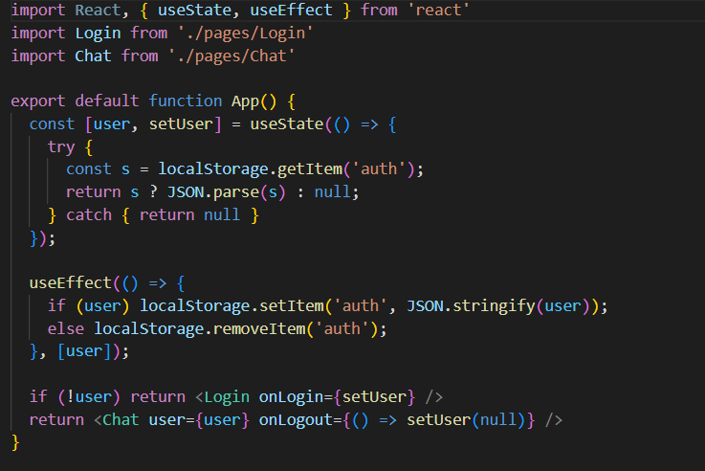

main.jsx

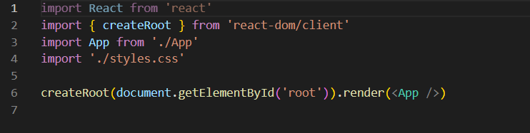

Chat.jsx

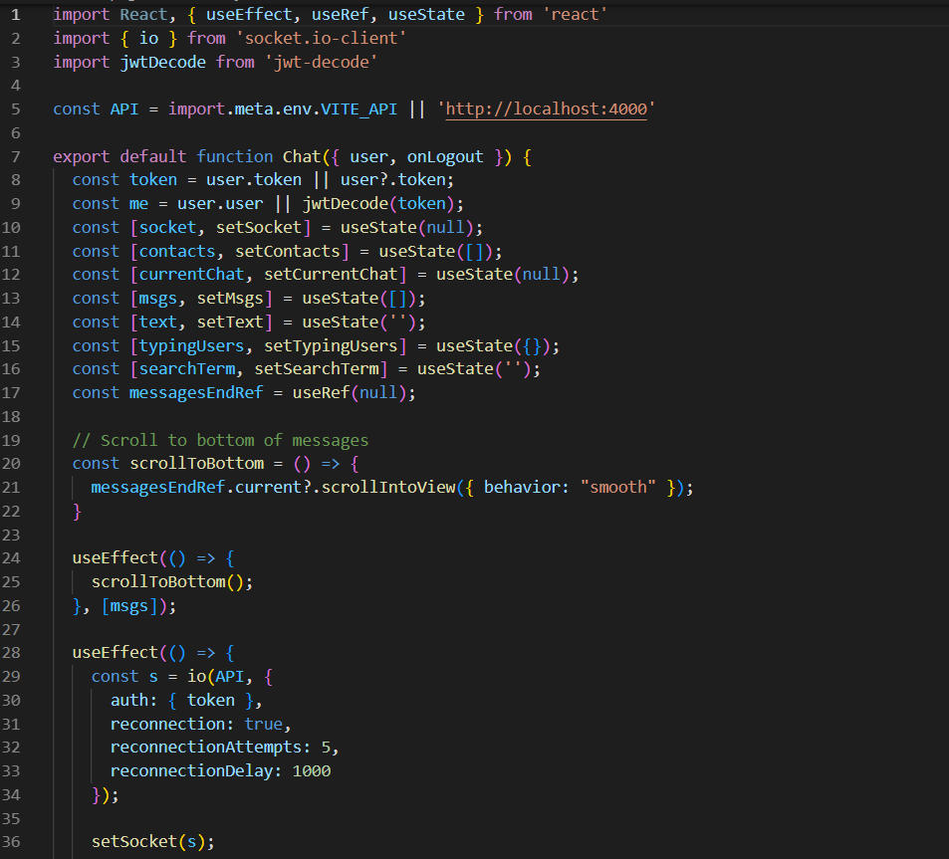

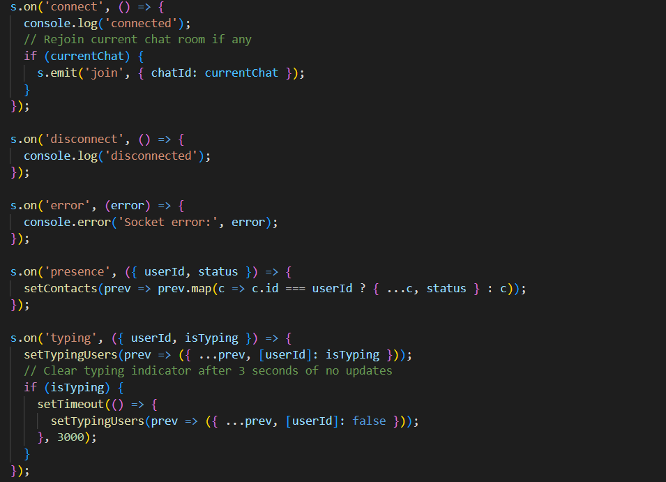

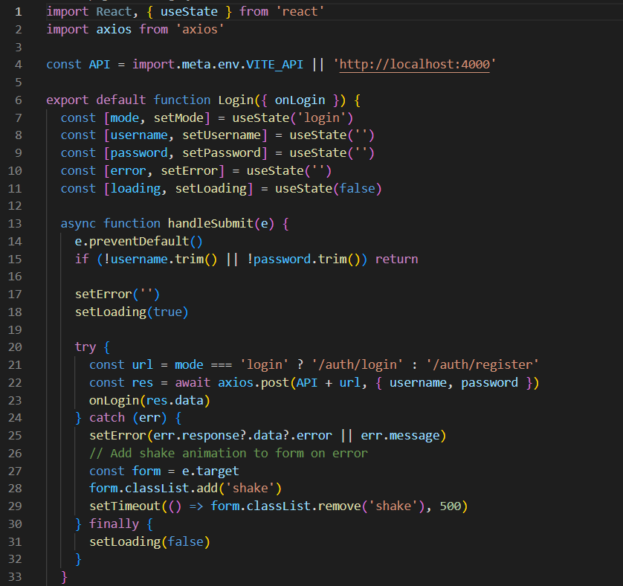

**Backend**

[server.js](http://serves.js)

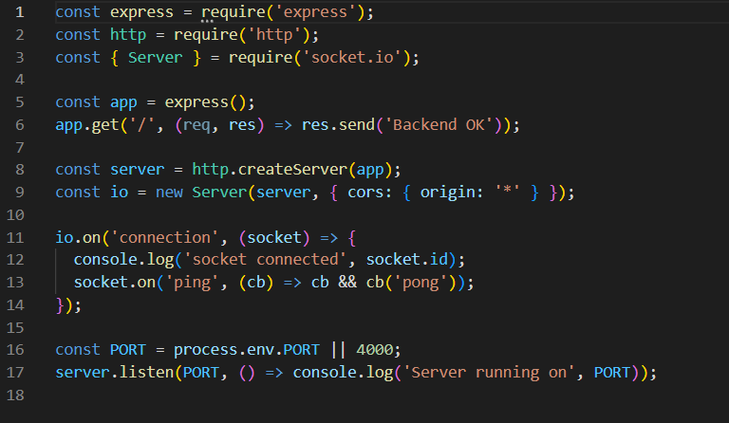

[index.js](http://index.js)

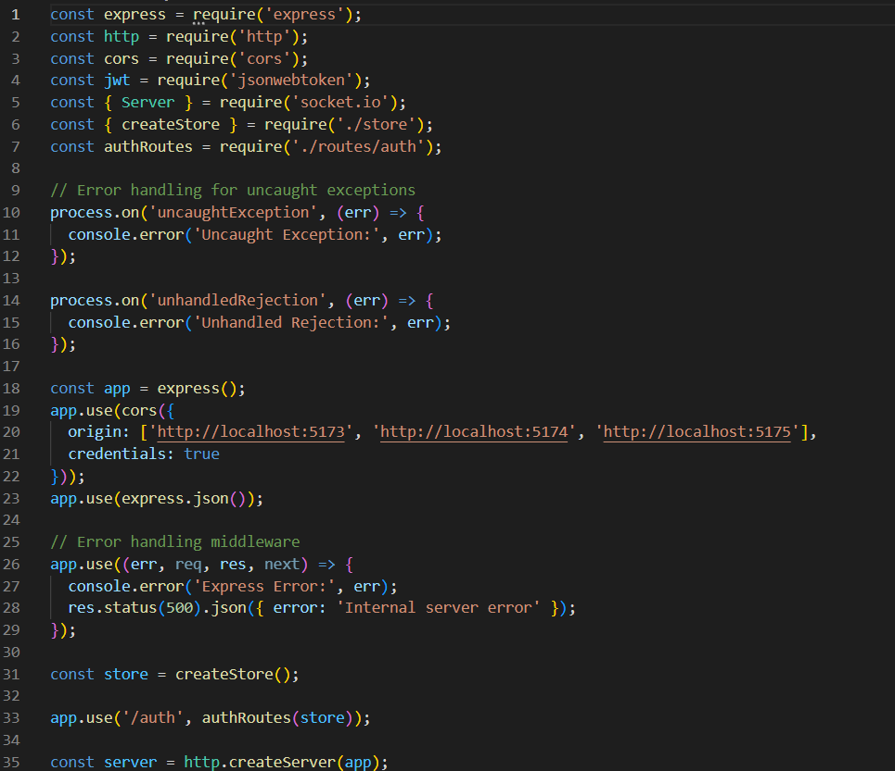

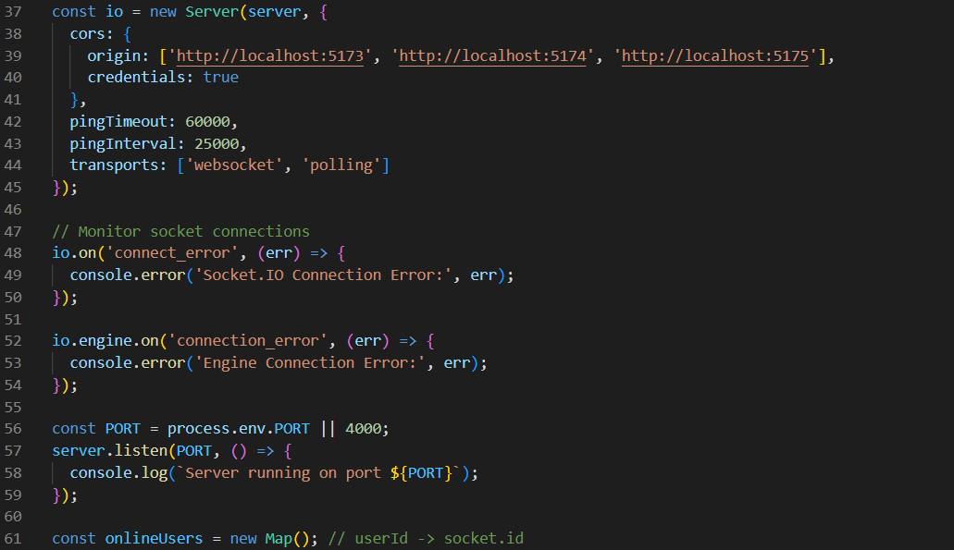

**Output:**

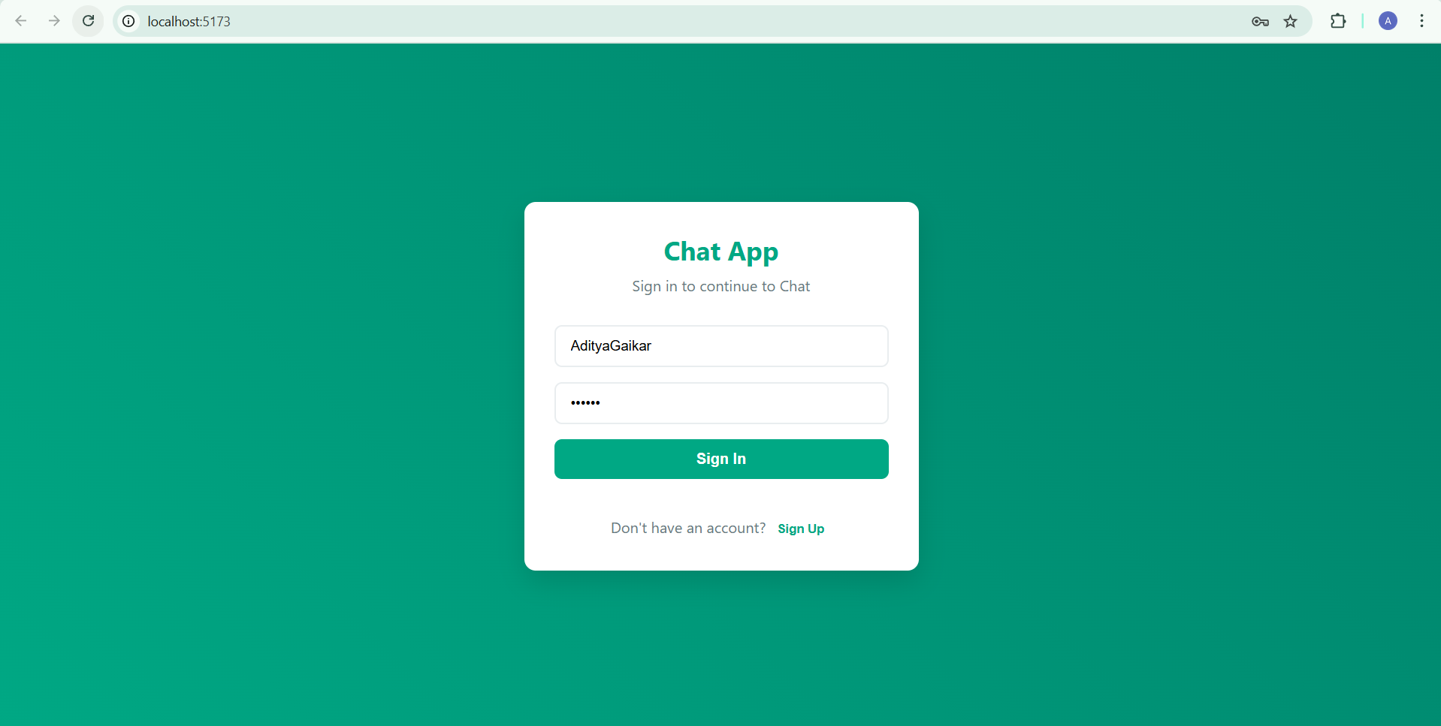

**FIGURE 1**: Sign in page for old users

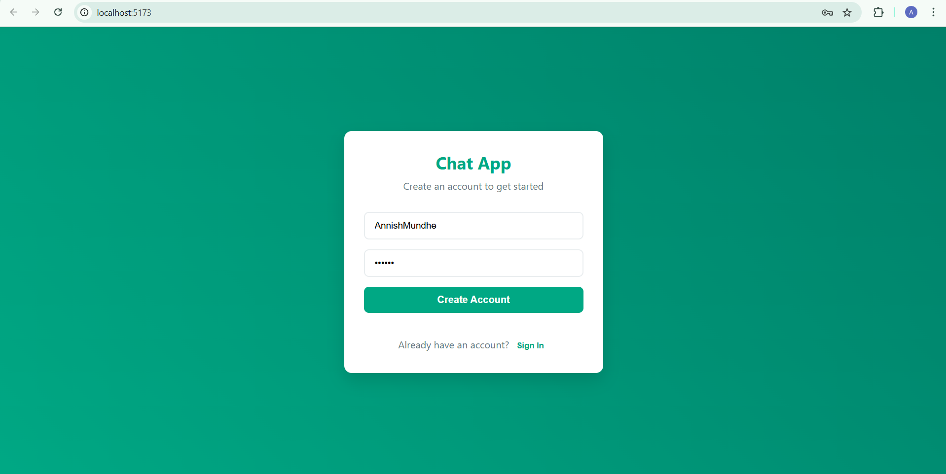

**FIGURE 2** : Registration page for new users

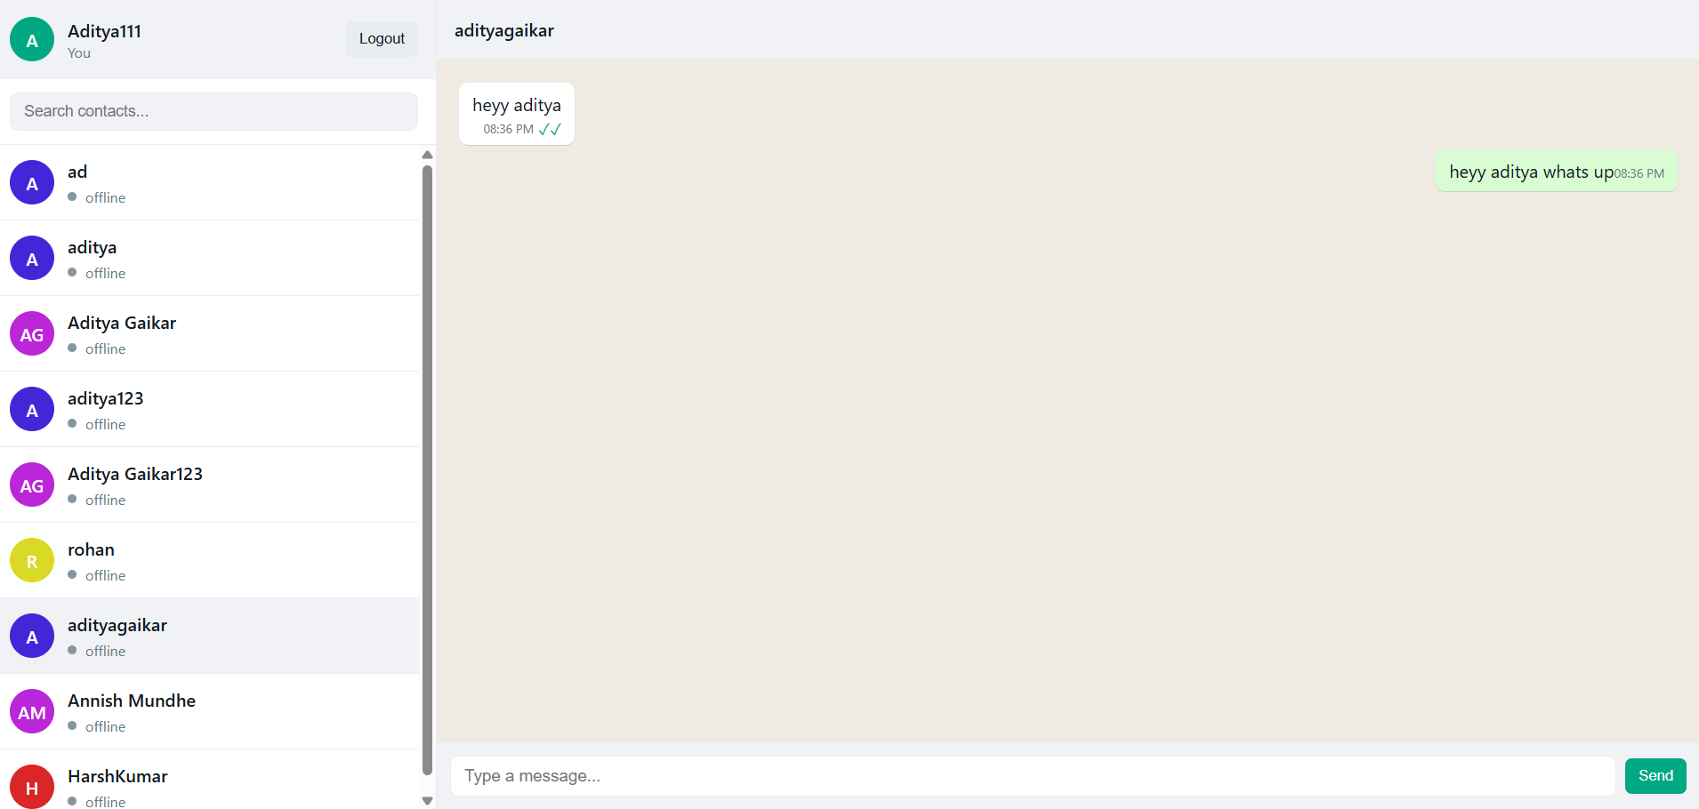

**FIGURE 3:** Chat-app interface

Github link :https://github.com/adiityagaiikar/Websocket-ChatApp_Aditya